Certificate of Appreciation
Presented to Tim Rowe

In recognition of indispensable
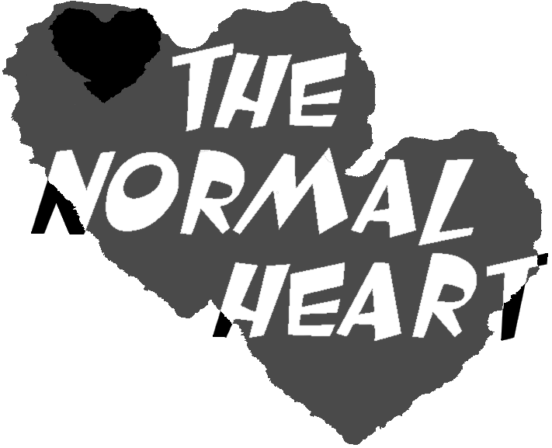

support for the presentation of The Normal Heart at Wright State University’s Jubilee Theatre

Nicholas Barnard
Director and Producer

The Normal Heart

Jubilee Theatre Production

