Certificate of Appreciation
Presented to Michael Kersh

In recognition of indispensable
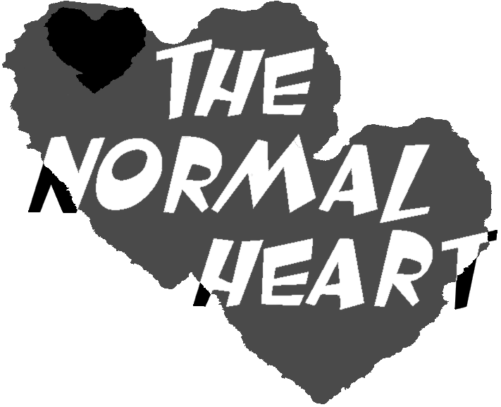

support for the presentation of The Normal Heart at Wright State University’s Jubilee Theatre

Nicholas Barnard
Director and Producer

The Normal Heart

Jubilee Theatre Production

