Certificate of Appreciation
Presented to PFlag Dayton

In recognition of indispensable support for the presentation of The Normal Heart at Wright State University’s Jubilee Theatre
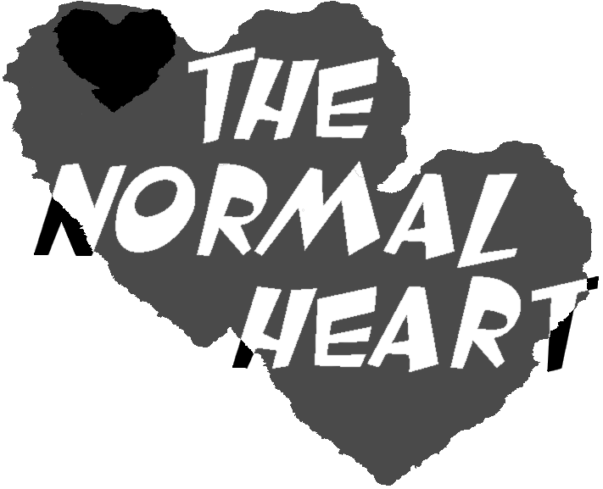

Nicholas Barnard
Director and Producer
The Normal Heart

Jubilee Theatre Production

