Impassioned writing...explosively powerful...uniquely important —The Advocate
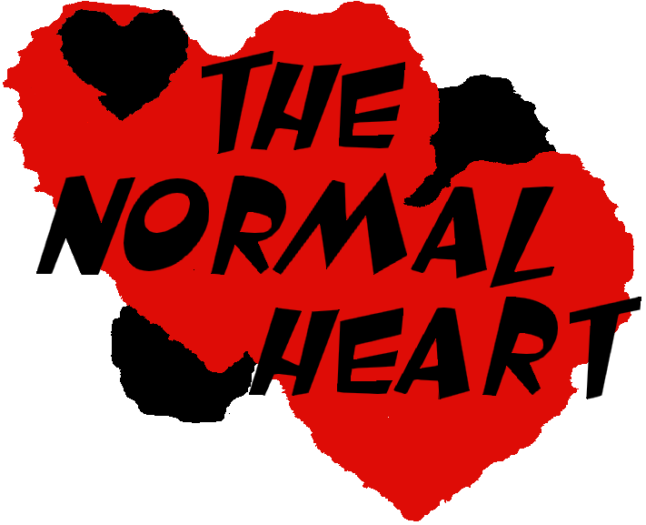
One of the 100 Greatest Plays of the Twentieth Century - Royal National
Theatre of Great Britain

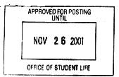

By: Larry Kramer

Directed by: Nicholas Barnard

November 16th, 17th and 18th at 8PM at the Wright State’s Jubilee Theatre (T131CAC)
An extraordinary play! It is bracing and exciting to hear so much passion and intelligence. Kramer produces a cross fire of life-and-death energies that create a fierce and moving human drama. --Jack Kroll, Newsweek
Jared Anderson as Tommy Boatwright | Jason Dunlap as Grady
Scott Gray as Hiram Keebler | Meghan Lawniczak as Dr. Emma Brookner
Patrick McCarty as Micky Marcus | Mark Mozingo as Ben Weeks
Adam Michael Rihacek as Bruce Niles | BJ Solomon as Felix Turner
Cory Trares as Ned Weeks
Light Design: Brandon Francis
Properties Master: Jayme Swisher
Stage Manager: Sarah Stair

For more information on The Normal Heart
please call Nick at 937-885-4773
Produced by special arrangement with SAMUEL FRENCH, INC.

