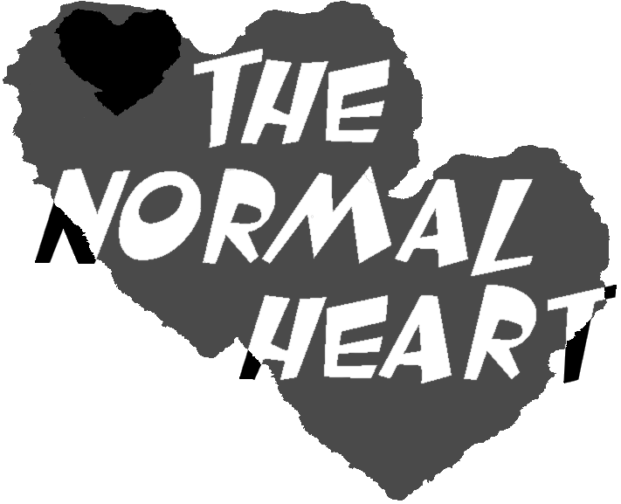

By: Larry Kramer

Directed by: Nicholas Barnard

Jubilee Theatre

Wright State University

November 16th, 17th and 18th at 8pm

Presented with generous support from:
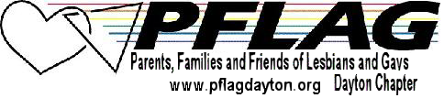
The windiest militant trash
Important Persons shout
Is not so crude as our wish:
What mad Nijinsky wrote
About Diaghilev
Is true of the normal heart;
For the error bred in the bone
Of each woman and each man
Craves what it cannot have,
Not universal love
But to be loved alone.

All I have is a voice
To undo the folded lie,
The romantic lie in the brain
Of the sensual man-in-the-street
And the lie of Authority
Whose buildings grope the sky:
There is no such thing as the State
And no one exists alone;
Hunger allows no choice
To the citizen or the police;
We must love one another or die.

W. H. Auden
From “September 1, 1939”

The Normal Heart is presented with generous support from PFLAG (Parents, Families and Friends of Lesbians and Gays), Dayton Chapter. PFLAG meetings are held the second Tuesday of each month at 7:30pm at St. John’s Church in Dayton. Call 937-299-0534 for additional information.

The Jubilee Theatre is a Student Managed, Student Produced, Student Supported Theatre. If you would like to provide support to this and future productions please place your donations in the donation box at the front of the theatre. You may also mail a check made out to "Wright State University Directing Lab Fund" with the memo “The Normal Heart” to: Wright State University, Department of Theatre Arts, c/o Victoria Oleen, 3640 Colonel Glenn Hwy, Dayton, Ohio 45435-0001.
Cast
(In Order of Appearance)
Craig Donner | Jared Anderson
Mickey Marcus | Patrick McCarty
Ned Weeks | Cory Trares
David | Scott Gray
Dr. Emma Brookner | Meghan Lawniczak
Orderly | Jason Dunlap
Orderly | Mark Mozingo
Bruce Niles | Adam Michael Rihacek
Felix Turner | Bernard Solomon
Ben Weeks | Mark Mozingo
Tommy Boatwright | Jared Anderson
Hiram Keebler | Scott Gray
Grady | Jason Dunlap
Examining Doctor | Scott Gray
Orderly | Jared Anderson

Crew
Director | Nicholas Barnard
Stage Manager | Sarah Stair
Light Designer | Michael Fende
Light Board Operator | Sarah Stair
Costume Designer | Sarah Stair
Properties Mistress | Jayme Sue Swisher
Properties Crew Chief | Jason Dunlap
Multi-Media Operator | Scott Gray

Special Thanks to:
Brian Barnard, Robert Barnard, Matthew Benjamin, Andrea Burns, John Lavarnway, Stuart McDowell, Randi McNeil, Minuteman Press, Victoria Oleen, Molly Rice, Tim Rowe, and James Wilger.
Produced by special arrangement with SAMUEL FRENCH, INC.
Act One
Scene 1: The office of Dr. Emma Brookner | July 1981
Scene 2: Felix’s desk at the New York Times | September 1981
Scene 3: Ben’s law office | October 1981
Scene 4: Ned’s apartment | November 1981
Scene 5: Ned’s apartment | March 1982
Scene 6: Ben’s law office | May 1982
Scene 7: Ned’s apartment | October 1982

Act Two
Scene 8: Emma’s apartment | October 1982
Scene 9: A meeting room in City Hall | October 1982
Scene 10: Emma’s office | October 1982
Scene 11: The organization’s old office | February 1983
Scene 12: Emma and the Examining Doctor
Scene 13: Organization’s new offices-to-be | April 1983
Scene 14: Ned’s apartment
Scene 15: Ben’s law office | May 1984
Scene 16: Felix’s hospital room | May 1984

Bios
Jared Anderson is a freshman musical theatre major. His past roles include Jesus in Godspell, Malvolio in Twelfth Night, and John Jasper in the Mystery of Edwin Drood. His hobbies include computers, reading fantasy novels, and singing.

Nicholas Barnard is a junior theatre studies major. He is from Dayton, Ohio. Last year he directed Mixed Up Molly Eden in the Jubilee Theatre. He also was the light board Operator and Electrician for the Jubilee Theatre production of Welcome to the Moon and other plays. He worked on the Festival Playhouse productions of 1903: Wings of Dreams where he was on the costume crew, and Inherit the Wind where he was on the properties crew. He has previously directed, written plays, acted, designed sound, and was a puppeteer at The Miami Valley School in Dayton, Ohio. He is also a member of the Jubilee Theatre Board. He wishes to thank everyone who made this show possible, especially is talented actors, designers and crew.

Jason Dunlap is a sophomore here at Wright State University. He is originally from Perrysburg, Ohio. He attended the Ohio State University last year where he was an acting major. His past productions include: The Odd Couple, To Absent Friends, Once upon a Wolf, and Bye Bye Birdie. Jason would personally like to thank Fred (that guy in the green sweater) for helping him make it through those long nights of rehearsals. Personal favorites include going to concerts, things that are orange and girls.

Michael Andrew Fende is a freshman this year at Wright State majoring in design technology. He hopes to get a job at a well-known theatre when he graduates. He thanks his family and friends for support and he also thanks the director, Nick Barnard, for this opportunity. God bless all!

Scott Gray is a junior in the mass communications program. He hopes to become a major film director in Hollywood. He was in Little Mary Sunshine as Ranger Hank and Henry Coldwater in Three Murders and Its only Monday.

Meghan Rose Louise Lawniczak is a 20 year old, junior theatre studies major. She was born and raised in a small town right outside of Toledo, Ohio. Meghan is not a stranger to the stage having started her performing career at the age of 13 in Oklahoma. Since then she has been in Camelot, Arsenic and Old Lace, Cinderella, Anything Goes with the Black Swamp Players, The Wizard of Oz, and had the leading role as the Narrator in Joseph and the Amazing Technicolor Dreamcoat. She also had the esteemed privilege of being a production assistant and singer for the United States premiere of Woza Albert! at Bowling Green State University where she attended for one year as an acting major. Meghan is also a talented singer, having been trained as a classical and Broadway singer since the age of ten. She has performed at car shows, Harley Davidson shows, and had the honor of performing at the opening of Cedar Point this year. This is Meghan’s first show at Wright State and she wishes to thank her mother, Pam and brother, Matthew for all their support of her dreams to act and sing. She dedicates her performance to her father, who, if nothing else, was always proud of her ability to light up a stage.

Patrick McCarty is a first year musical theatre major from Toledo. He is very happy to be performing his debut show at Wright State University. He has performed past shows such as Fiddler on the Roof, Once Upon a Mattress, The Crucible, and A Mid Summer Night’s Dream. He would like to thank his friends and family for all of their encouragement and support. He enjoys the company of his friends, college life, and girls.

Mark Mozingo is a freshman acting major, and is quite excited about his first performance opportunity at Wright State University. His previous shows include Into the Woods, Annie Get your Gun, Charlotte’s Web, Once Upon a Mattress, and the Miracle Worker. He is a member of the 2000 Kentucky Governor’s School for the Arts graduation class, and worked as a summer apprentice this past year at the Lexington Children’s Theatre. He’d like to thank his parents for allowing him the opportunity to fulfill his dream.

Adam Michael Rihacek is a freshman acting major from Perrysburg, Ohio. He as performed in The King Stag as King Deramo at the University of Toledo and in the American Dream as Daddy. He was an Assistant Director at Perrysburg High School in 1999 and 2000. He likes ramen noodles, the color blue, tato skins, flavor ices, his family, Harry Potter, and girls.

Bernard J. Solomon is a freshman musical theatre major from New Jersey. His most recent credits include Angels in America: Peristraika, Oliver, Hello Dolly, and Joseph and the Amazing Technicolor Dreamcoat. BJ is very happy to be at Wright State University and looks forward to a great four years. Special thanks to Sarah, Mark, Keeli and all of my new friends. I love you guys. (and girls.)

Sarah Stair is a freshman musical theatre major from Knoxville, Tennessee. After years of dancing and singing on stage she is excited about her first ever backstage position. She would like to thank the cast for not giving her too much grief. Enjoy the show!

Jayme Sue Swisher is a sophomore design technology major Property Major. She transferred from the University of Kentucky. She has built props for the Dayton ballets production of A Christmas Carol in December 1999. She has worked on several Wright State productions at the Festival Playhouse including A Streetcar Named Desire where she was on the property crew and Lost in Yonkers where she was the Property Crew Chief.

Cory Trares is a freshman acting major from Perrysburg, Ohio. His past roles include Oscar in The Odd Couple, Kenickie in Grease, Reverend David in The Foreigner and Reuben in Joseph and the Amazing Technicolor Dreamcoat. Cory likes The Lord of the Rings, Memento, Our Lady Peace, and girls.
Directors Notes
Two weeks ago, I saw Rent in Cincinnati. All throughout the show I developed the belief that Rent never should have happened. All criticisms of Rent aside, I just believed that the events that inspired Rent should not have happened, and therefore Rent should not have been written.
I then speculated on the origins of why AIDS spread wildly in the gay community, especially the gay community in New York City. Ultimately I came to the conclusion that it spread because of indiscriminate sex among gay men. But, more importantly indiscriminate sex was rampant because of the lack of the ability for gay men to openly date, and develop intimate relationships on a without sexual contact early on in the relationship.
Fast forward to 2001, and move to the Midwest. How much has changed? It would not be fair to say that the Midwest of 2001 resembles the NYC of 1981, but the same behaviors still exist. The bars have been replaced by the Internet; the bathhouses have been replaced by private dwellings, and hotel rooms; the closet has been replaced by… well nothing. For many gay men, especially young men, the closet is still an implicit part of their lives.
Many people will disagree with this, and they are right to an extent, many more people are out of the closet, but often only in certain situations. Gay men will exhibit public displays of affection unrivaled by any couple homo or heterosexual in a private place, a gay day at an amusement park, or a gathering at a friends house. But these same men when in a public situation will not even hold hands, as any straight couple would.
On October 31, 2001, The Ohio House of Representatives passed a bill dubbed the Ohio Defense of Marriage Act. In actuality it serves to deny the normalization of homosexual relationships. Anyone who knows a gay couple knows that they posses the same love, the same commitment, and a normal heart like heterosexual relationships.
I invite you to enjoy this evening of theatre, but I also urge you to understand the real meanings in this show to society today: AIDS exists, and those closest to dying, their lovers, have no legal right to be by their side when they die. To this end, there are several documents on the walls of the theatre for you to take note of at your leisure. Enjoy the Show!

