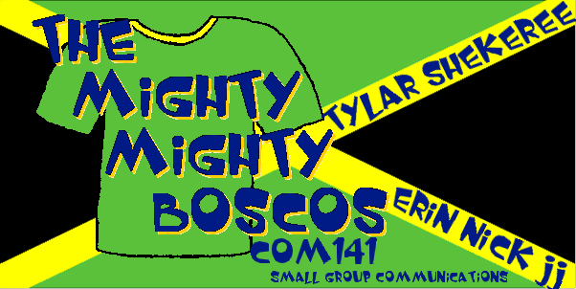
The Mighty Mighty Boscos

Nicholas Barnard

Tylar Bertie

Shekeree Sanders

JJ Engelbert

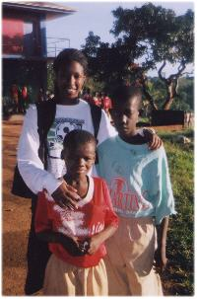
Erin Kister

