January 31, 2002
Hello to the Boys at Bosco,
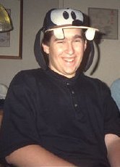
My name is Nicholas Barnard; my picture is to the left. I’m a college student at Wright State University. It is in Dayton, Ohio in the United States of America.
I’m a theatre major at Wright State. That means that I am learning about plays and musicals, and all of the things around it. I know how to act, and sing. I sort of know how to dance.
The theatrical skill that I am currently learning how to direct. Directing is making sure the show is united and everything fits together. One of the major jobs of directing is working with the actors and getting their performances to fit together. This can take several weeks of continually watching the same show over and over again, making suggestions to the actors on how to act in their roles.
I just directed a play called The Normal Heart. I started directing it at the beginning of September, and it took me to November until it was performed. Quite a long time of working on one project but it was well worth it.
This quarter of the school year, I am not working on any theatre projects. Instead I am working on several computer websites, and the clothing donation project for your school. I’m really having a great time, but I am working really hard, staying up till three and four in the morning and getting up at nine or ten in the morning almost everyday.
Well I hope you enjoyed this letter, and study hard in school.
Take care,

Nick Barnard

