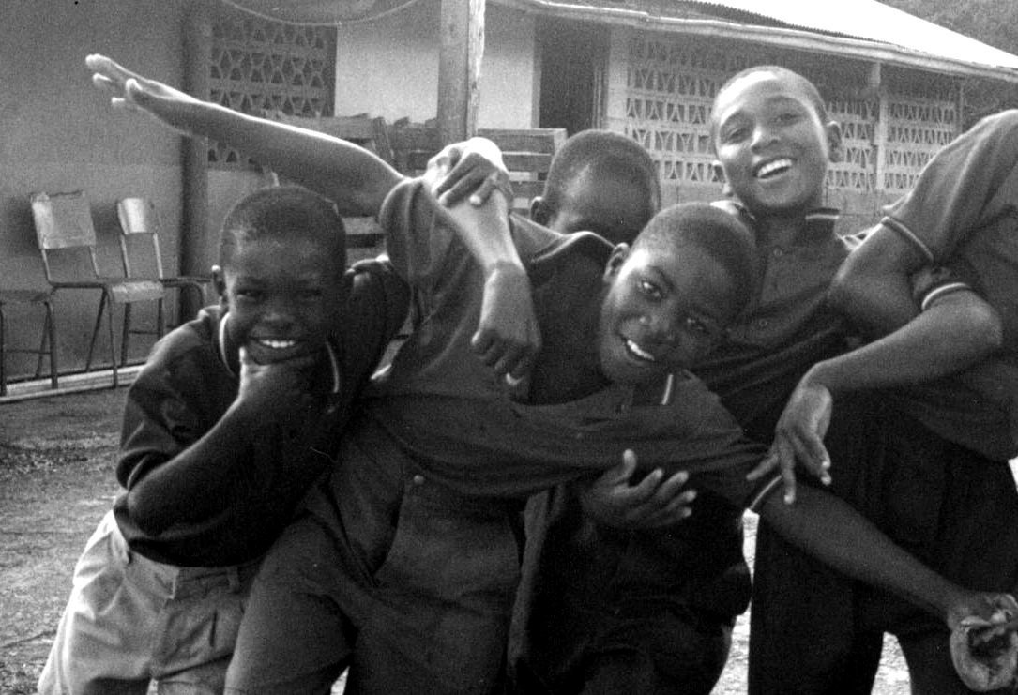
What can you do to help these kids?

Get rid of your old clothes.
Donate clothes to the Bosco Orphanage in Mandville, Jamaica in the Student Union on February 4th, 5th, 6th, 12th, 13th, and 14th
Donations of boys and mens clothes accepted.
New, unused underwear accepted as well.
Visit the donation table in at:
Contact JJ at 395-1523 or Shekeree at 775-1617 for more information
In the Morning | In the Afternoon
Feb 5 | Feb 4
Feb 12 | Feb 6
Feb 14 | Feb 13

Visit http://go.to/boscoboys/
for more information

