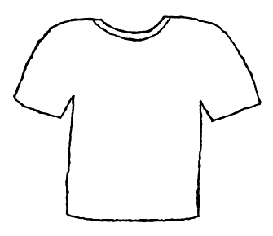
Help Boys in Saint John Bosco’s Orphanage in Mandville, Jamaica

Donate a Dollar
Get your name on a T-Shirt
on the wall.

Visit http://go.to/boscoboys/
for more information

